EMAIL NOTIFICATION CONFIGURATION IN JENKINS

PREQUESITES:

* Jenkins installed ec2 instance
* Port: publicip:8080
* Gmail for notifications
* 2 step Authentication on {must}

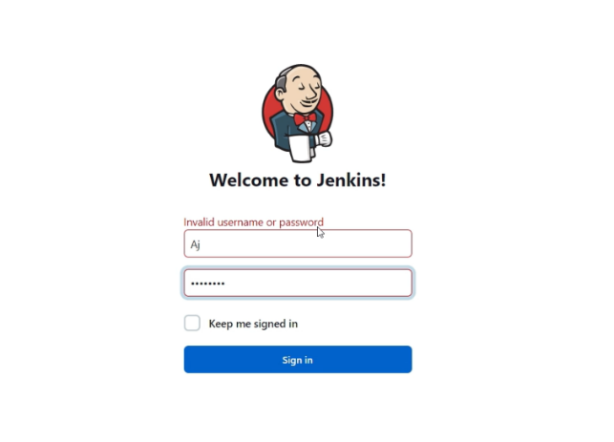

* Log into Jenkins account

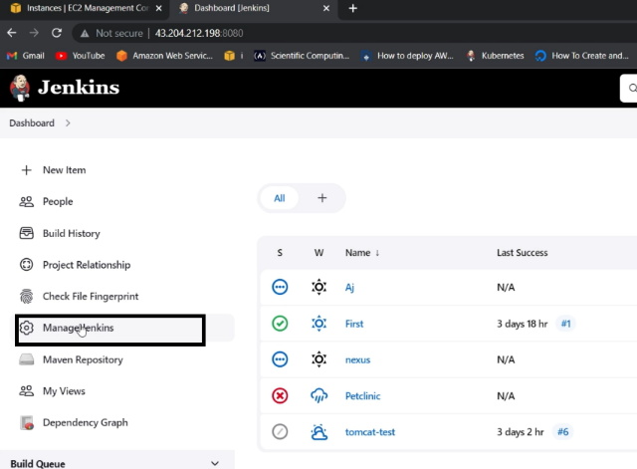

* Select Manage Jenkins

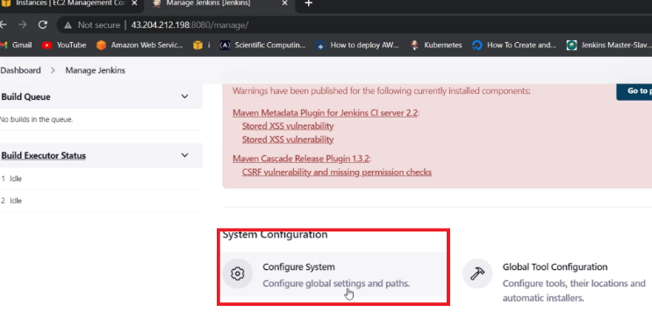

* In Manage Jenkins, select Configure system

Go to deep down to find E-mail Notification like below picture:

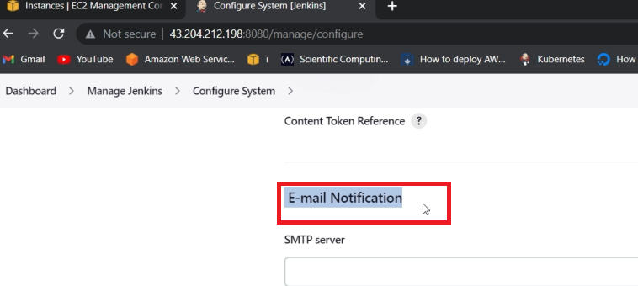

SMTP server : smtp.gmail.com

Use SMTP Authentication checkbox

Username: your mail

Password : mail password

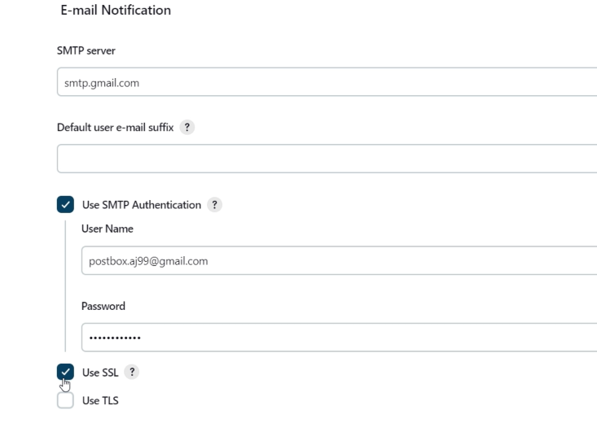

* Use SSl checkbox

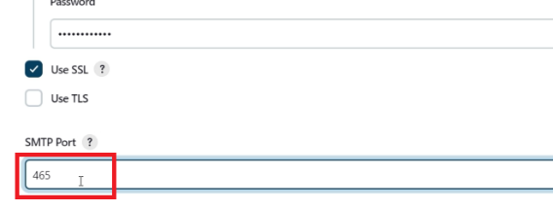

Port : 465

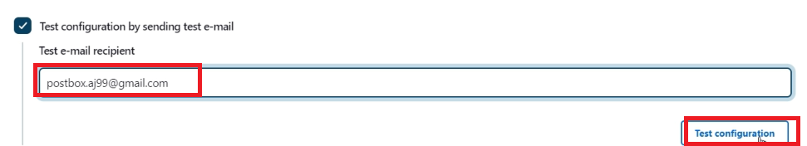

* Enter your Mail and click on Test configuration.

You will get this error

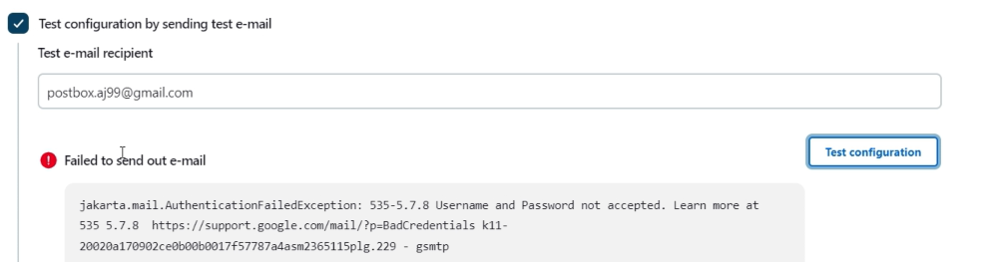

Because From May 30,2022 Google stopped Third party apps to allow

So we use this process:

Select your Gmail on Right top profile

To see below like picutre

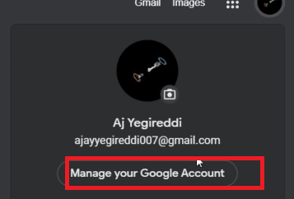

🡪 Click on Manage your Google Account

And select security under Home section like below picture

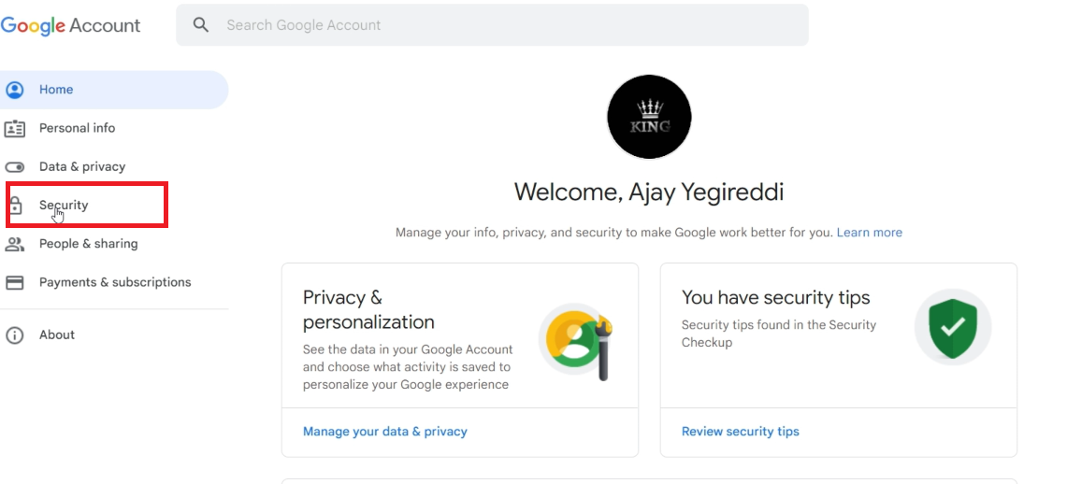

Now we need to ON 2 step Authentication:

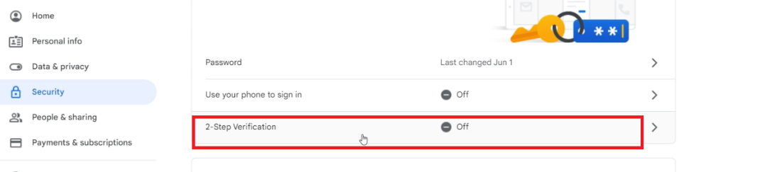

Click and enter your mail password after once you click

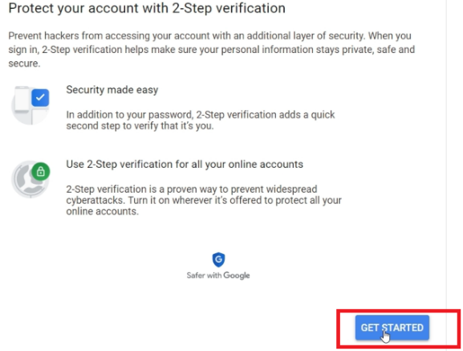

Click on Get started

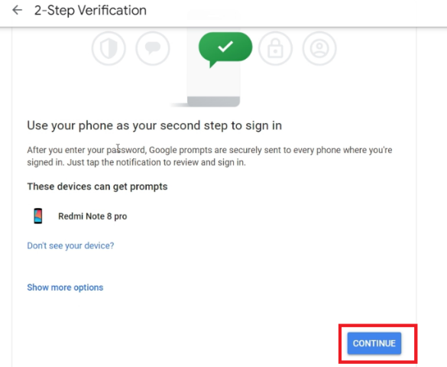

Click on Continue

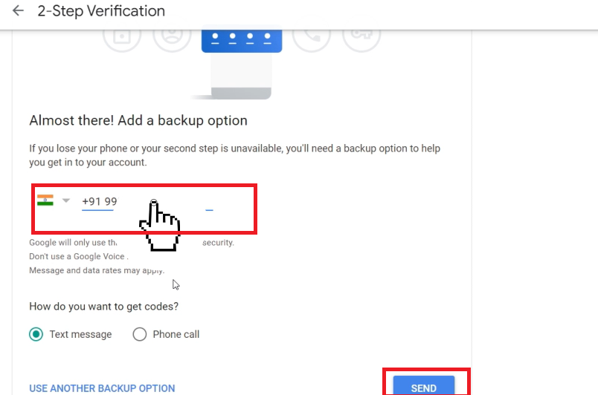

Enter your Mobile number And click Send

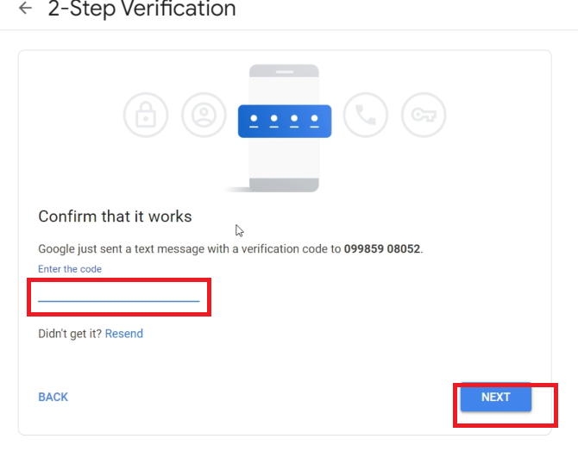

Enter otp and click NEXT

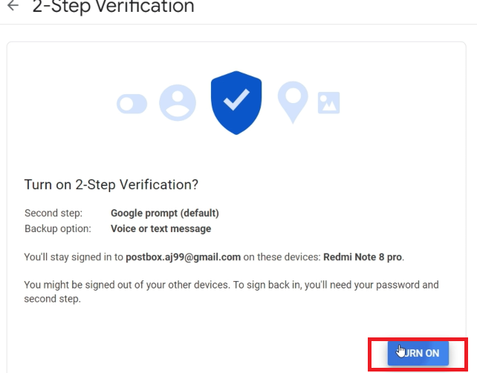

TURN ON And come back

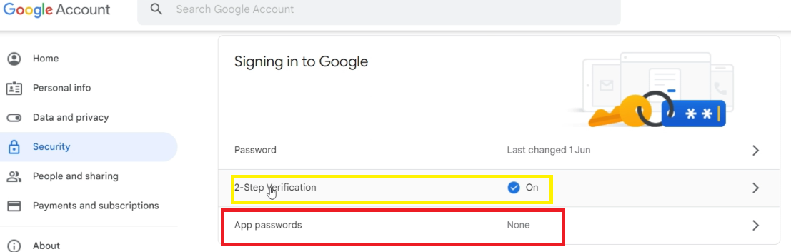

Select App passwords

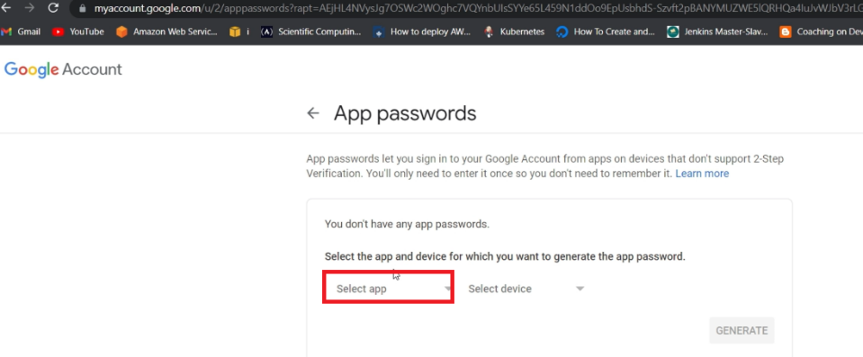

Select App and enter custom name to JENKINS

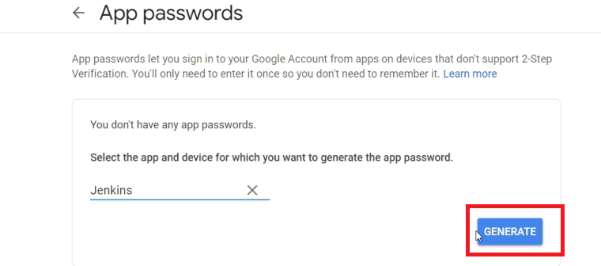

Click on GENERATE

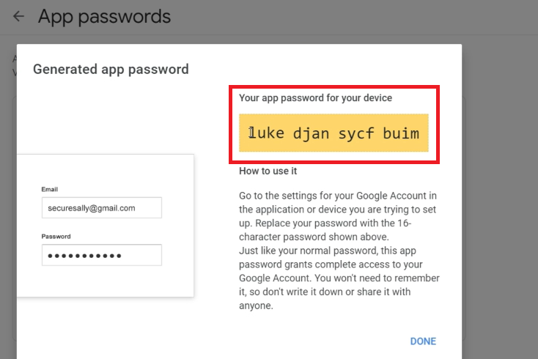

You will get above picture like password inside Yellow colour

And copy it

And come back Jenkins dashboard in Browser

And click ON Manage Jenkins

And inside it select Configure System

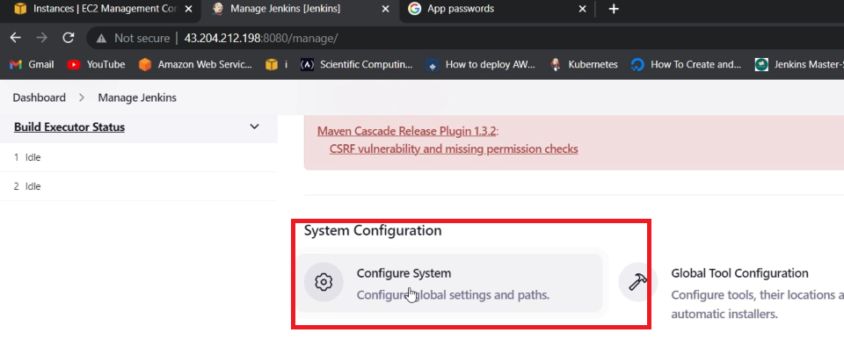

ABOVE PIC FOR REFERENCE

Under Email –notification

Edit your mail password that copied from last yellow colour

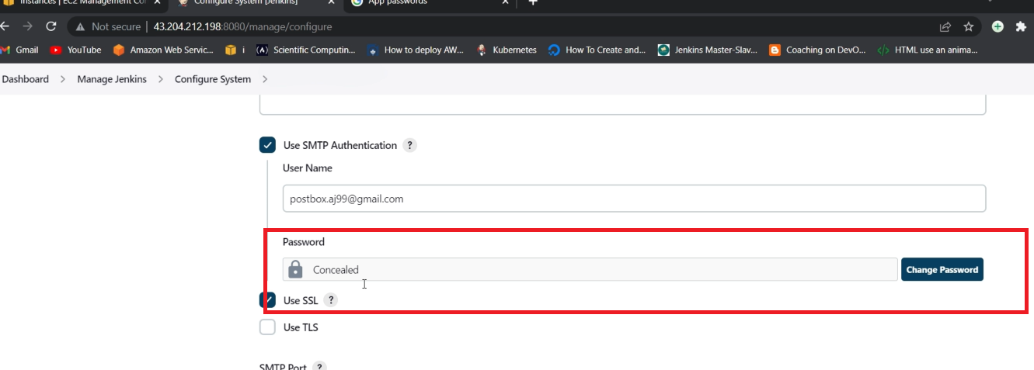

Paste it and apply

And in Test configuration

Check by entering mail and

Click on Test configuration

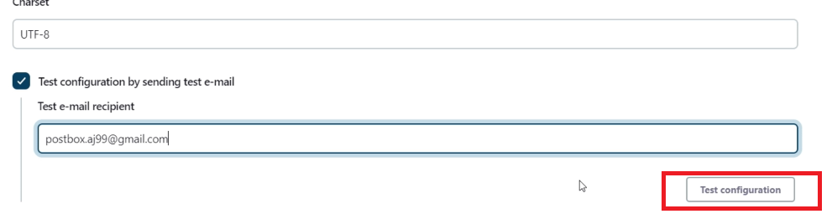

And check

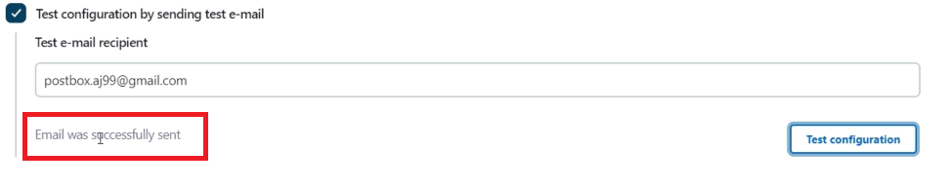

You will get above pic Refer

And In Jenkins

Select New item

And enter name and select free style job and click ok

And use manual process for maven project

In the post build actions select for Editable email notification select

And enter mail in receiptents

If build Failure or Email not sent

Add your mail and password in the extended email section

And add copied password and enable debug mode

Watch completely video